EXPERIMENT -2
ROLL NO:240701495 NAME: Sherin Katherina D

USER INTERFACE AND DESIGN
COMAPARSION OF UI DESIGN BETWEEN TWO FIGMA CREATION

Design a UI where users recall visual elements (e.g., icons or text chunks). Evaluate the effect of chunking on user memory

FRAME 1 : INSTRUCTION SCREEN
CHUNKING PHASE:
Analysis of the Memory Recall Task – Instruction Screen
This screen represents the orientation and preparation phase of the Remember Game, where users are guided before starting the memory challenge.
1. Purpose of the Screen
- This screen explains how the memory game works.
- It prepares users to observe, memorize, and recall icons accurately.
- It sets clear expectations about the importance of attention and accuracy.
2. Key Elements and UI Components
Game Title – “REMEMBER GAME”
- Identifies the application and its purpose.
Instruction List (1–6)
- Describes the complete flow: observation, memorization, recall, and scoring.
Start Button
- Begins the memory challenge.
- Moves the user into the chunking phase.
3. How This Screen Supports Chunking
- Users are informed that they must carefully observe the icons.
- They are encouraged to store information in memory.
- This prepares the brain to form chunks in the next screen.
4. Cognitive and UX Benefits
- Reduces confusion.
- Increases focus and readiness.
- Improves task understanding.
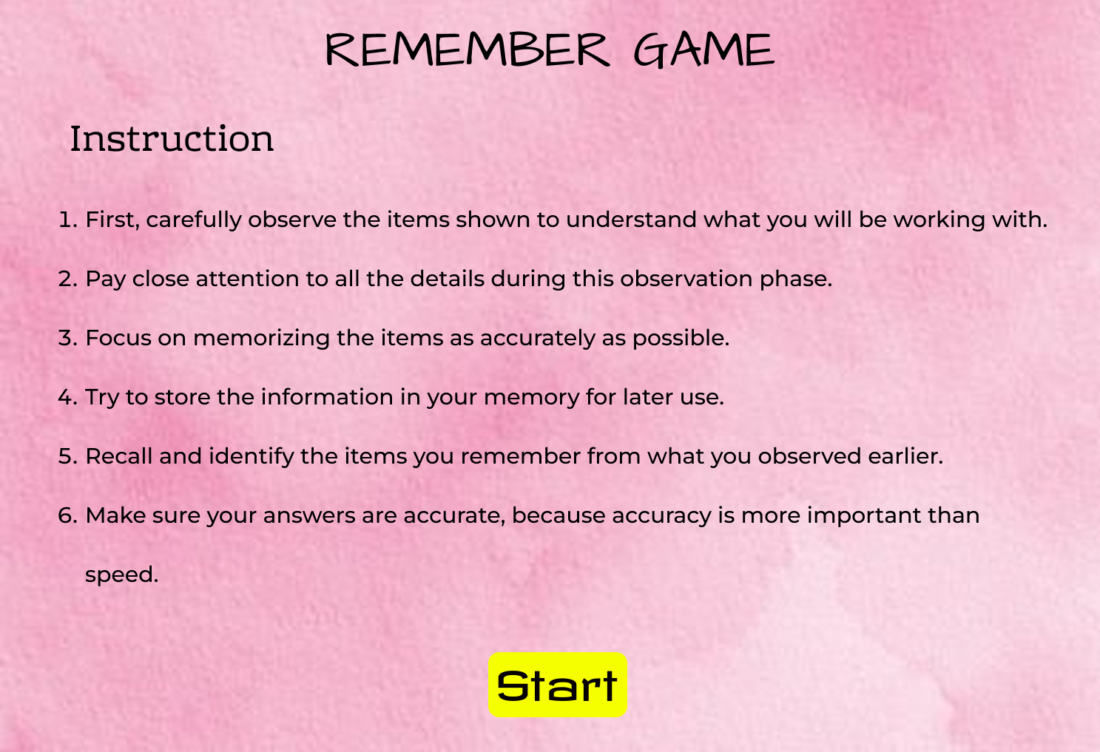

FRAME 2 : REMEMBERING ICONS
CHUNKING PHASE:
Analysis of the Memory Recall Task – Chunking Phase Screen
This screen represents the visual memory encoding phase, where users memorize different icons under time pressure.
1. Purpose of the Screen
- Users view and mentally group multiple icons.
- The chunking strategy helps them remember similar items as groups.
2. Key Elements and UI Components
Countdown Timer (5 sec)
- Shows how long the user has to observe.
- Creates urgency and concentration.
Progress Bar
- Visually represents remaining time.
Grid of Icons
- Icons include:
  - Emoji with sunglasses
  - Laughing emoji
  - Ghost
  - Victory hand
  - Bread
  - Magnet
  - Old woman face
  - Purple face
- Several icons appear repeatedly, enabling chunking.
3. How the Chunking Phase Works
- Users detect repeated icons.
- They group items like emojis, food, and objects.
- These grouped items are stored as memory chunks.
4. Cognitive and UX Benefits
- Improves visual memory.
- Encourages pattern recognition.
- Reduces mental overload.
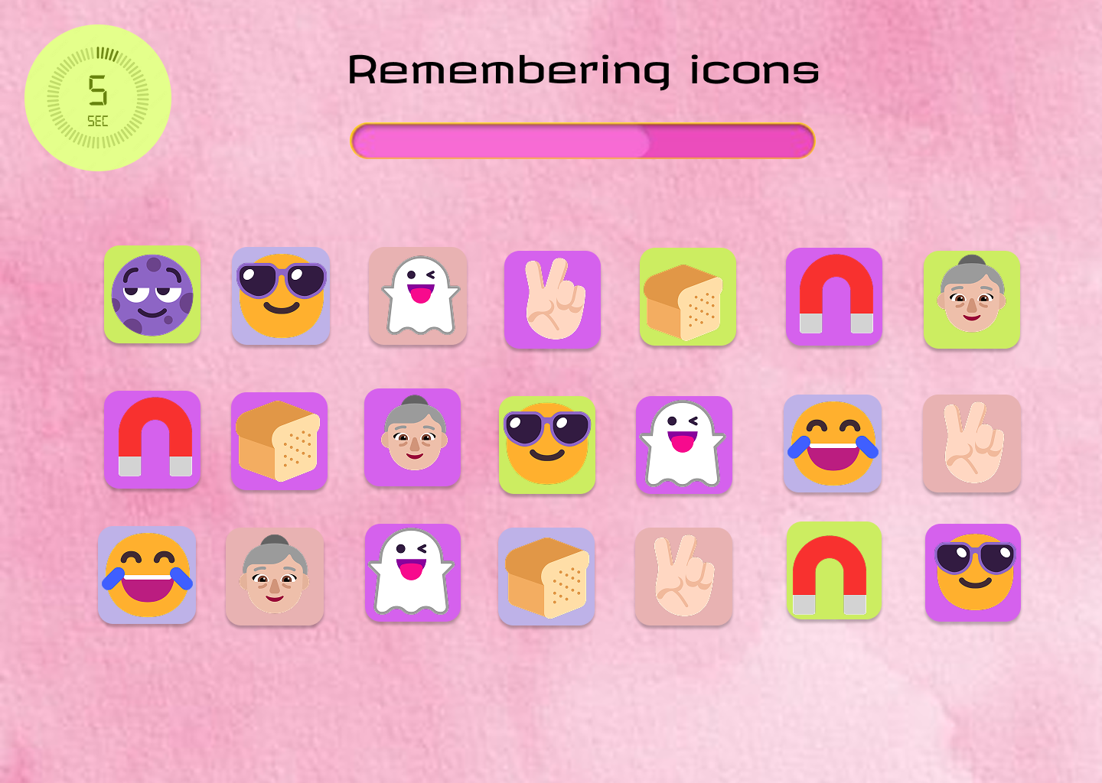

FRAME 3 : RECALL ZONE
CHUNKING PHASE:
Analysis of the Memory Recall Task – Recall Phase Screen
This screen tests how accurately users remember the icons from the chunking phase.
1. Purpose of the Screen
- Users must select or identify the icons they saw earlier.
- It measures memory recall and recognition.
2. Key Elements and UI Components
Displayed Icons
- Includes:
  - Sunglasses emoji
  - Ghost
  - Victory hand
  - Old woman
  - Bread
  - Magnet
Selection Indicators (Dots)
- Show which icons have been selected.
NEXT Button
- Submits the selected answers.
3. How Recall Works
- Users compare icons with their memory.
- They choose only the ones they recognize.
- The system evaluates correctness.
4. Cognitive and UX Benefits
- Tests recognition memory.
- Improves attention and decision-making.
- Reinforces memory accuracy.
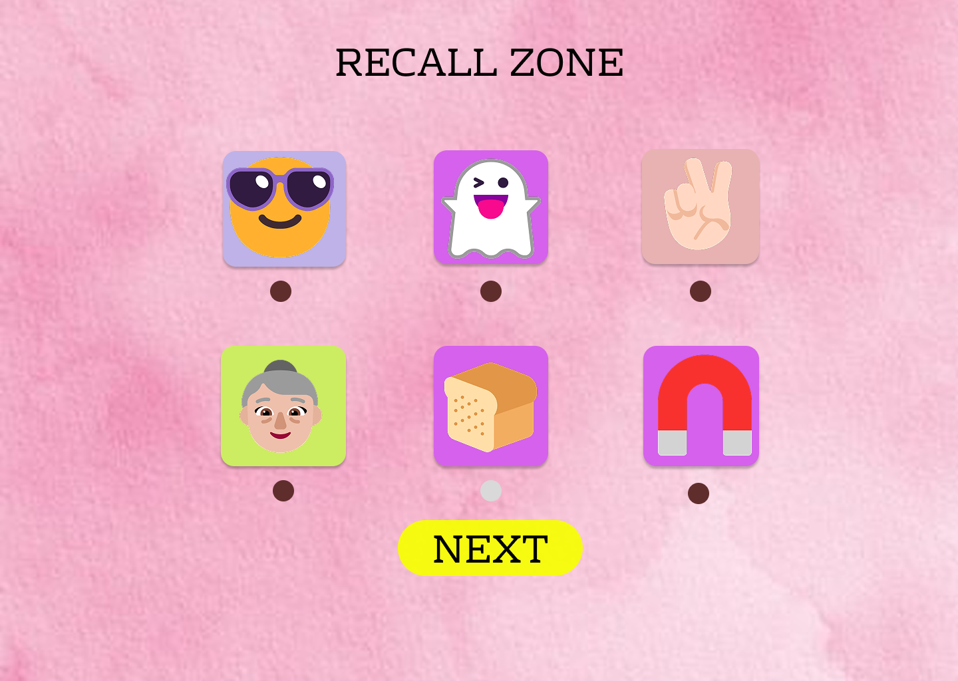

FRAME 4 : RESULT SCREEN
CHUNKING PHASE:
Analysis of the Memory Recall Task – Result Screen
This screen displays the final performance of the player.
1. Purpose of the Screen
- Shows how well the user remembered the icons.
- Provides feedback on memory performance.
2. Key Elements and UI Components
Score Display (e.g., 5/6)
- Shows correct answers out of total.
Restart Button
- Allows replay to improve memory.
Home Button
- Returns to the main menu.
Exit Button
- Closes the game.
3. How This Screen Supports Learning
- Users receive immediate feedback.
- They can retry and improve.
- Encourages repetition and learning.
4. Cognitive and UX Benefits
- Motivates users.
- Reinforces memory skills.
- Makes learning fun and engaging.
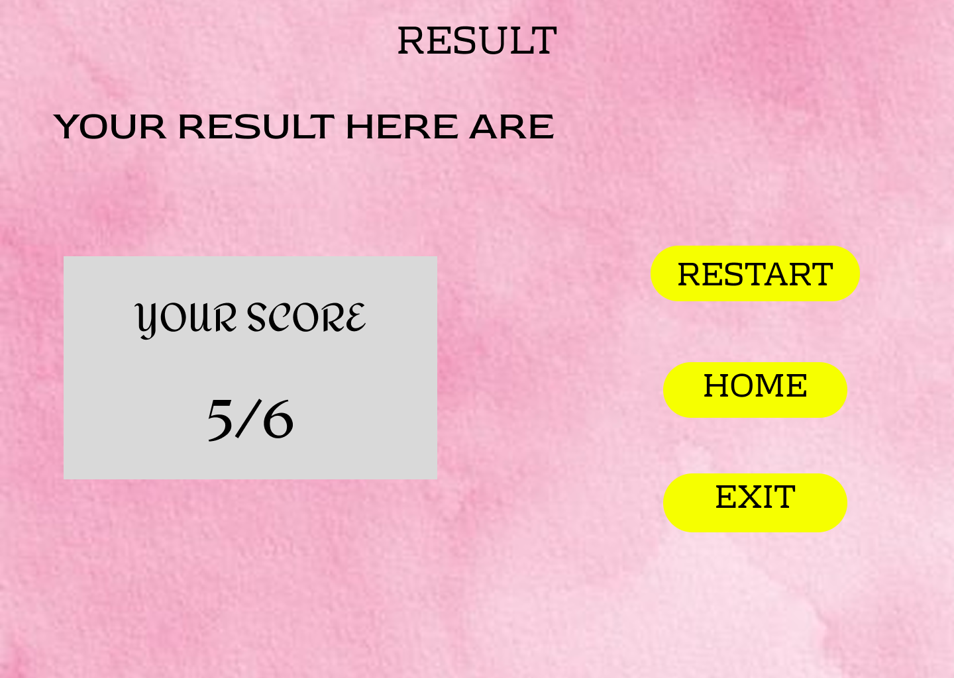

PROTOTYPE LINK:
https://www.figma.com/proto/UgWuOPo9HdHX2oSAIY3qdP/sherin-expement-2?node-id=21-22&t=RKPA88qdQKUK3Zq8-0&scaling=min-zoom&content-scaling=fixed&page-id=0%3A1

